**IMS Product News**

**Market Event**

|  |  |  |  |
| --- | --- | --- | --- |
| **Date:** | 02/13/14 | **ID:** | 1311 005 03 |
| **Subject:** | Health Insurance Exchange – Update to HIX Plans & Medicaid Expansion Update | **Offering:** | Xponent Plantrak, Plantrak, Plantrak Co-Pay, FIA, Plantrak Market Dynamics, Xponent Plantrak Dynamics, RXBD, PayerTrak |
| **Market:** | All | **Channel:** | Retail |

**Summary:**

**Additional details are now available regarding the Health Insurance Exchange (HIX) Plans, as well as an update on Medicaid expansion.**

**Background:**

We previously communicated that IMS added new payers and plans representing the base structure of the Health Insurance Exchange (HIX) plan. Attached is the previous communication.



**Updates:**

**Health Insurance Exchange (HIX) Plans**

The early weeks of 2014 RX utilization highlight that HIX volume is likely to be masked within existing commercial business. As a reminder, this is an industry concern since the ACA legislation did not include a mandate for unique identifiers on Rx transactions like the Medicare D legislation. The chart below provides a listing of the HIX Plan IDs that are tracking volume as of week ending 01/31/2014.

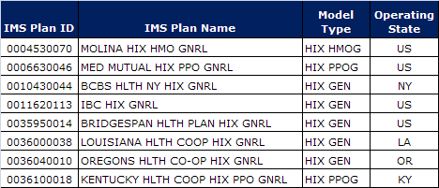

To fully assess the visibility into HIX utilization and provide guidance, IMS Health is performing analysis on the data received; however, at least several months of data will be required as input around this major healthcare event to allow for:

* Stabilization of industry utilization as customary each new year but compounded by a major industry event for 2014
* Data mining and identification of additional unique HIX industry codes allowing for more granularity
* Assessment of key HIX payers and HIX volume versus overall payer utilization
* Collaboration with data suppliers for additional industry insights from point of service transactions
* Correlation to enrollment numbers, if provided and substantiated as accurate

**Medicaid Expansion**

Overall Medicaid retail Rx utilization is experiencing an uptick starting in January 2014. As expected, states that opted for Medicaid expansion are displaying a more significant uptick in Rx utilization most notably CA, KY, AZ, WV, OR, CO, OK and WA.

**Next Steps and Recommendations:**

More high level guidance will be provided on the topic of Medicaid expansion and HIX coverage as available.

**Contact Information:**

Please contact your IMS Client Service team with any questions.